

Nama : Abdurrohman

NIM : 210511035

Kelas : R1 (T121A)

Tugas Minggu 1:

Buatlah 3 buah class ( Fahrenheit, Reamur, dan Kelvin) yang mengimplementasikan OOP dimana setiap class memiliki kemampuan untuk melakukan konversi ke Temperatur yang lain.

Jawaban berupa 3 buah screenshot script beserta hasilnya dikirim ke email (freddy.wicaksono@umc.ac.id) dengan subject: **Tugas-1 PBO2 2023**

SCRIPT CLASS SUHU:

1. Fahrenheit
2. Reamure
3. Kelvin

#Nama :Abdurrohman

#Nim  :210511035

#Kelas:R1(TI21A)

class fahrenheit:

    def __init__(self,f):

        self.fahrenheit=f

    def fahrenheit_to_celcius(self):

        F = (5/9) * (self.fahrenheit-32)

        return F

    def fahrenheit_to_reamur(self):

        R = (4/9) * (self.fahrenheit-32)

        return R

    def fahrenheit_to_kelvin(self):

        K = (self.fahrenheit-32)* 5/9 + 273

        return K

F_C = 75

FahrenheitA = fahrenheit(F_C)

print("Konversi",F_C, "derajat fahrenheit adalah:", {FahrenheitA.fahrenheit_to_celcius()}, "derajat Celcius\n")

F_R = 60

FahrenheitB = fahrenheit(F_R)

print("Konversi",F_R, "derajat Fahrenheit adalah", {FahrenheitB.fahrenheit_to_reamur()}, "derajat Reamur\n")

F_K = 90

FahrenheitC = fahrenheit(F_K)

print("Konversi",F_R, "derajat Fahrenheit adalah", {FahrenheitC.fahrenheit_to_kelvin()}, "derajat Kelvin\n")

print("-"*100)

#Nama :Abdurrohman

#Nim  :210511035

#Kelas:R1(TI21A)

class reamur:

    def __init__(self,r):

            self.reamur=r

    def reamur_to_celcius(self):

        F = (5/4) * (self.reamur)

        return F

    def reamur_to_fahrenheit(self):

        R = (9/4) * self.reamur+32

        return R

    def reamur_to_kelvin(self):

        K = (self.reamur/0.8) + 273

        return K

R_C = 75

ReamurA = reamur (R_C)

print("Konversi",R_C, "derajat reamur adalah:", {ReamurA.reamur_to_celcius()}, "derajat Celcius\n")

R_F = 60

ReamurB = reamur (R_F)

print("Konversi",R_F, "derajat reamur adalah", {ReamurB.reamur_to_fahrenheit()}, "derajat Fahrenheit\n")

R_K = 90

ReamurC = reamur (R_K)

print("Konversi",R_K, "derajat reamur adalah", {ReamurC.reamur_to_kelvin()}, "derajat Kelvin\n")

print("-"*100)

#Nama :Abdurrohman

#Nim  :210511035

#Kelas:R1(TI21A)

class kelvin:

    def __init__(self, k):

        self.kelvin = k

    def kelvin_to_fahrenheit(self):

        F =  (self.kelvin*9/5) - 459.67

        return F

    def kelvin_to_reamur(self):

        R = (4/5) * (self.kelvin-273)

        return R

    def kelvin_to_celcius(self):

        K = self.kelvin - 273.15

        return K

k_F = 75

KelvinA = kelvin(k_F)

print("Konversi",k_F, "derajat kelvin adalah:", {KelvinA.kelvin_to_fahrenheit()}, "derajat Farenheit\n")

k_R = 60

kelvinB = kelvin(k_R)

print("Konversi",k_R, "derajat kelvin adalah", {kelvinB.kelvin_to_reamur()}, "derajat Reamur\n")

k_C = 90

kelvinC = kelvin(k_C)

print("Konversi",k_R, "derajat kelvin adalah", {kelvinC.kelvin_to_celcius()}, "derajat celcius\n")

print("-"*100)

LINK GITHUB : https://github.com/Abdurrohman1

SCREENSHOT CLASS SUHU:

1. Fahrenheit

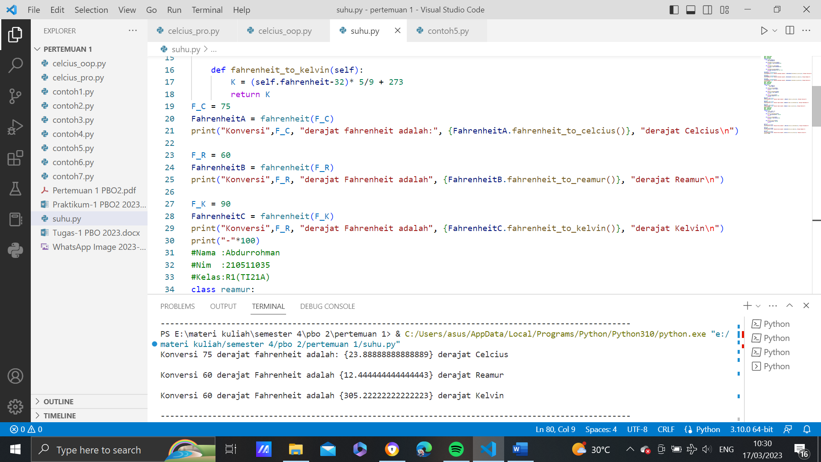

1. Reamure

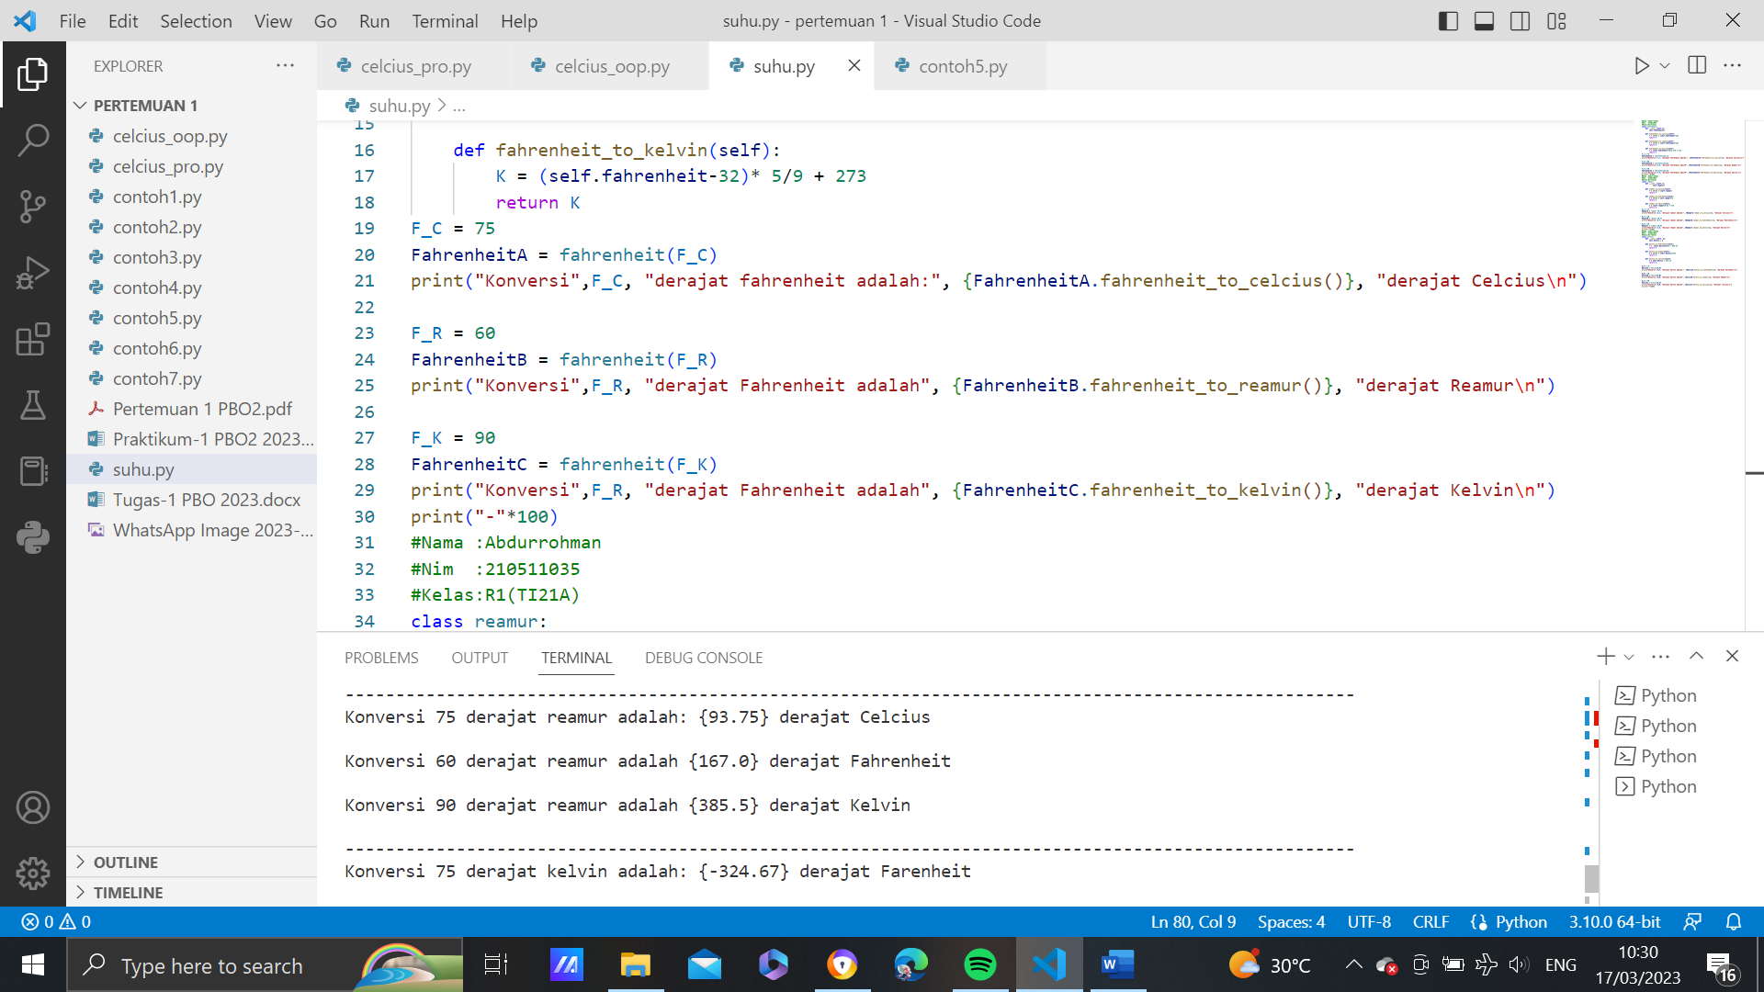

1. Kelvin

